Randomized controlled trial of fixation versus no fixation of posterior malleolus fractures

(PMF) associated with Weber B ankle fractures (PMFIX)
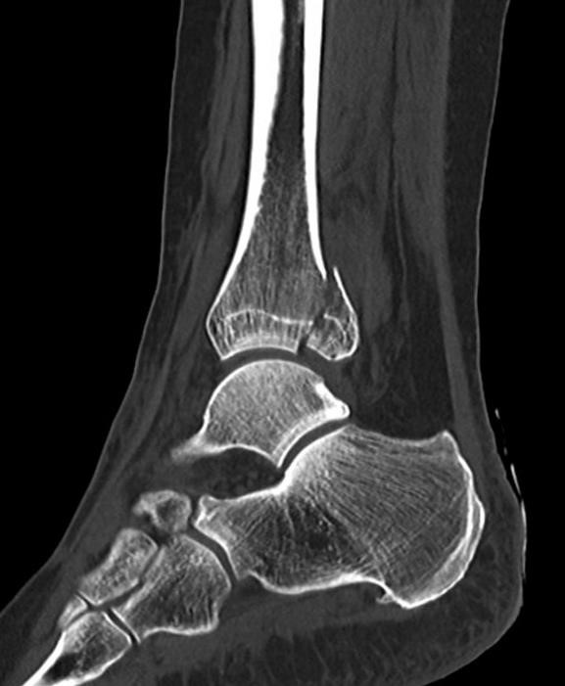
Ankle fractures constitute 9% of all fractures and have an incidence of approximately 187 per 100,000 persons per year. A posterior malleolar fragment (PMF) (Picture 1) is present in up to 46% of Weber B and Weber C fractures.¹
I.

Summary

Pilskog et. al. recently presented patients with a
PMF with patient reported outcome measures (PROM) significantly lower than the general population.^{2,3} Clinical outcome for ankle fractures with a PMF is known to be poor.^{2,4} For this reason, the indication and choice of intervention for these fractures has been the object of increased interest over the recent years. It is one of the most discussed areas within ankle fracture surgery. Traditionally, these PMFs have been treated with closed reduction and anteroposterior screw fixation, or even no fixation. A more novel posterior approach to the ankle for open reduction and internal fixation of smaller and medium sized PMFs is increasingly popular.⁵ However, there is no consensus to
Picture 1- Posterior malleolus fracture, marked with what the best treatment is. There are no
^{red arrow} available randomized controlled studies, and
most studies are retrospective and with a
variable number of patients. Few prospective studies are published.⁵

Through a multicenter prospective randomized controlled trial initiated from Haukeland University Hospital patients will be recruited and randomized to receive treatment with or without fixation of the PMF. Patients will be recruited at six study hospitals from all Regional Health Trusts in Norway. As there is no clear evidence supporting the choice to fixate, or not to fixate, the PMF, the study can contribute to new knowledge and a more evidence-based approach in treating these patients.

This study is important for several reasons:
- Patients of all ages are affected, in a study of 130 patients with PMF, 75% were aged 67 or younger. Thus, the injury potentially has a high impact on the rest of the patients working life and everyday life in interactions with family and friends
- The high number of these injuries and the potential for reduced function are underline the need for a consensus for best practice
- The cooperation of the largest trauma hospitals in Norway to find the this answer also underlines the interest and need
- The study may serve as a springboard for further multicenter studies for collaboration across the strongest professional orthopedic environments in Norway - The results of the study will have large international impact

II. Background

Ankle fractures constitute 9% of all fractures and has an incidence of approximately 187 per
100,000 persons per year. Seven per cent of ankle fractures are trimalleolar fractures. A posterior malleolar fracture is present in up to 46% of Weber B and Weber C fractures.¹ Traditionally, posterior malleolus fragments (PMF) have commonly been indirectly reduced and fixed when fragments involve 25% or more of the tibial articular surface, while smaller fragments are left unfixed.^{2,6} The posterior approach is increasingly popular and allows fixation of even smaller fragments.

Clinical outcome for trimalleolar fractures is known to be poor.^{2,4} For this reason, the indication and choice of intervention for these fractures has been the object of increased interest over the recent years. Many questions are, however, still unanswered. Despite lack of solid evidence there has been a trend towards use of a posterior approach allowing open reduction and internal fixation (ORIF).^{5,7,8} This approach is argued to allow more anatomical reduction of the PMF and fixation of fragments smaller than 25%.⁴⁸ In addition, fixation of the distal fibular fracture through the same incision gives good soft tissue coverage by the peroneus muscles.⁵⁰ The posterior inferior tibiofibular ligament (PITFL) attaches to the posterior malleolus and fixation of the PMF may therefore also reduce the need for syndesmotic screws.^{11–15} Several studies have demonstrated good clinical outcome and few complications using this posterior approach.^{10,16}

The posterior inferior tibiofibular ligament attaches to the posterior malleolus ¹⁴. It is advocated that anatomical reduction of the posterior malleolar fracture is indicated not only as a mean to reduce the risk for osteoarthritis because of the fracture per se, but also through anatomical fixation and healing of the posterior inferior tibiofibular ligament and the rest of the syndesmosis.^{11,12,15} Ovaska et. al.¹⁷ found that up to 50% of reoperations of ankle fractures with syndesmotic injury is due to malreduction of the fibula in the fibular notch and incorrectly placed syndesmotic screws. By fixating the posterior malleolar fracture by ORIF one can avoid complications, reoperations of malreduced fractures and the need for routine removal of the syndesmotic screws.

There are several case studies^{16,18–20} that show good clinical outcome and few complications using the posterolateral approach. These studies are, however, limited by inclusion of small cohorts, the comparison of anterioposterior fixation with non-fixation and their retrospective study design. Mason and Malloy report improved outcome⁵ with the use of a posterior approach for fixation of the posterior malleolus fragment. Further, they have also made a classification of the posterior malleolar fragments²¹. The authors of the most recent studies recommend the posterolateral approach due to the benefits and outcomes described above. A recent study by Pilskog et. al. comparing the traditional approach with the novel posterior approach showed equal patient reported outcome measures (PROM) for the two patient groups.² Although being a retrospective study the results challenge the growing conception that all PMF are in need of fixation. As such, there is a need for further high-quality studies on this area.

Through a multicenter prospective randomized controlled trial initiated from Haukeland University Hospital patients will be recruited and randomized to receive treatment with or without fixation of the PMF. Patients will be recruited at six study hospitals from all Regional Health Trusts in Norway. The study aims to help answer the question of whether or not the medium sized PMF need fixation. The intention is to deliver treatment recommendations for this type of fracture. This is one of the most discussed and debated topics within ankle fracture surgery. The project has a potential for high impact in the international orthopedic environment. The project further aims to yield a PhD-degree with several publications in internationally renowned peer-reviewed journals.

III. Project group
Jonas Meling Fevang, MD, PhD^{1,10} - Project leader
Jostein Skorpa Nilsen, MD² - Main Project coordinator
Kristian Pilskog, MD² - Main Project coordinator
Eivind Inderhaug, MD, PhD^{2,10} - Researcher, scientific advisor
Frede Frihagen, MD, PhD³ - Researcher, scientific advisor
Hendrik F. S. Fuglesang, MD, PhD⁴ - Project coordinator
Erik Sundqvist, MD⁵ - Project coordinator
John Clarke-Jenssen, MD, PhD⁶ - Project coordinator
Terje Meling, MD, PhD⁷ - Project coordinator
Morten Lysholm Steen, MD⁸ - Project coordinator
Kristian David Smogeli, MD⁹ - Project coordinator
Gunn Ørjansen Tvedt - Patient representative

- Chief of Orthopedic department, Haukeland University Hospital, Helse Vest
- Orthopedic department, Haukeland University Hospital, Helse Vest
- Orthopedic department, Østfold Hospital Trust
- Chief of Orthopedic trauma, Akershus University Hospital, Helse Sør-Øst
- Chief of Orthopedic trauma, St. Olav’s Hospital, Helse Midt
- Chief of Orthopedic trauma, Ullevål hospital, Oslo University Hospital, Helse Sør-Øst
- Orthopedic department, Stavanger University Hospital, Helse Vest 8) Chief of Orthopedic trauma, Helgeland Hospital, Helse Nord 9) Orthopedic department, Ålesund Hospital, Helse Midt.
10) University of Bergen, Clinical institute 1

IV. Aims of study
The main aim of the study is to compare PROM in patients who had fixation of the PMF with patient without PMF fixation with the intention to define what is the best surgical approach and treatment of the fractures in question.

The null hypothesis (H₀):
There is no difference in mean patient reported outcome (Self-Reported Foot and Ankle Score, SEFAS) in patients treated with fixation of the PMF and patients treated without fixation of the PMF (μ₁=μ₂).

The intention is to deliver treatment recommendations based on the study results. The results will thus have direct consequence for both patients and orthopedic surgeons.

Additional aims:
- Publish treatment recommendations for ankle fractures including a PMF
- Subanalysis of patients with and without syndesmotic injury
- Publish complication rate in the different treatment groups
- Health economic impact of ankle fractures

V. Method

Study design
The current study is a prospective, randomized, controlled trial (RCT) of Weber B ankle fractures involving the posterior malleolus. Based on the Mason and Molloy classification (Picture 1), PMF type 2 A and 2B will be randomized to either fixation or non-fixation of posterior malleolus.⁵ Mason and Molly type 2A and 2B fractures will be included in the study (Figure 1). Type 2 fractures are medium sized fractures of the posterior malleolus which involves the fibular incisura. They are classified as type 2A if only the posterior malleolus is fractured and as type 2B if there are two posterior fragments of the tibia in which the medial fragment extends to and involves the medial malleolus. Results will also be stratified according to 2A and 2B.

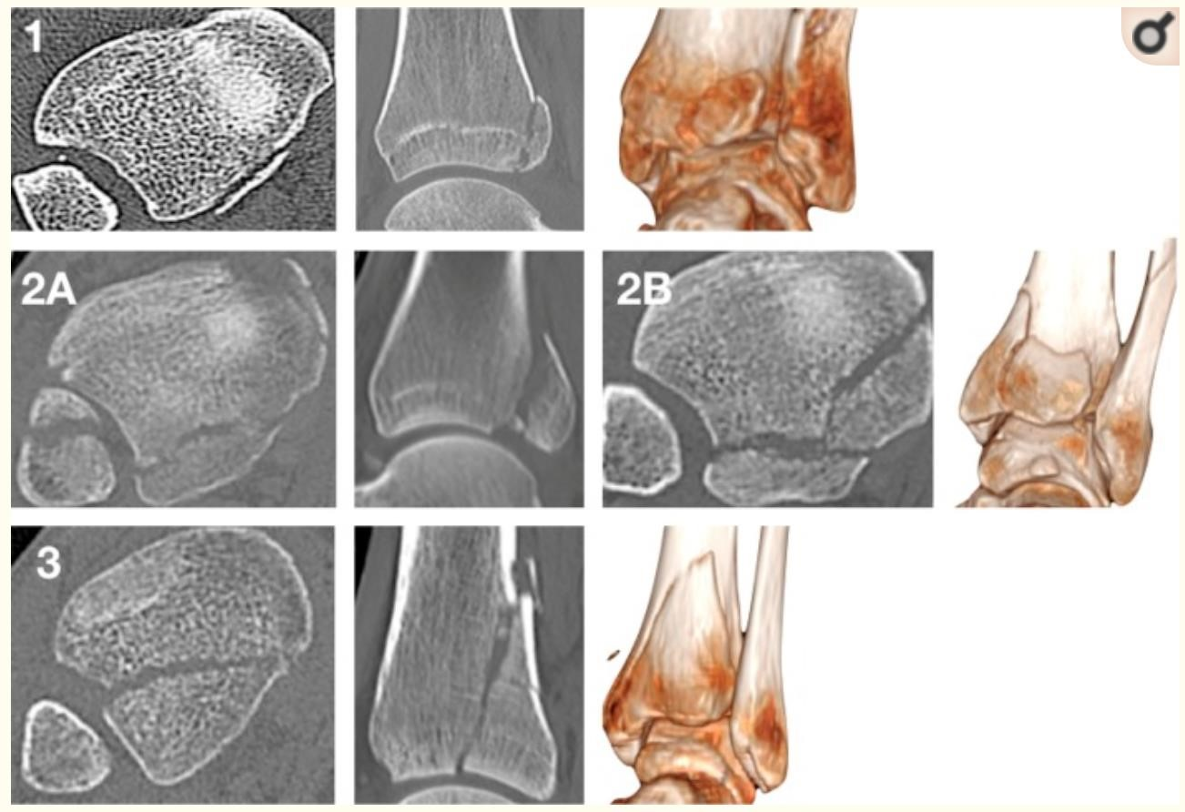
Picture 2 - Mason and Molloy classification of posterior malleolus fractures.⁵
Type 2 fractures are medium sized fractures of the posterior malleolus which involves the fibular incisura. They are classified as type 2A if only the posterior malleolus is fractured and as type 2B if there are two posterior fragments of the tibia in which the medial fragment extends to and involves the medial malleolus.

Inclusion criteria:
- Posterior malleolar (PM) fracture, of Mason & Molly type 2A/2B, associated with Weber B lateral malleolar fracture, with or without medial malleolar fracture
- Age 18-65 years
- For inclusion axial CT images are examined:
- Posterior malleoli >= 2 mm displaced (CT axial, sagital or coronal plane)
- Measurements are performed 5 millimeter (mm) cranial to the tibia plafond
- Posterior malleolus fractures involving less than 40% of the fibular notch are included. See Figure 2 for illustration of measurements.

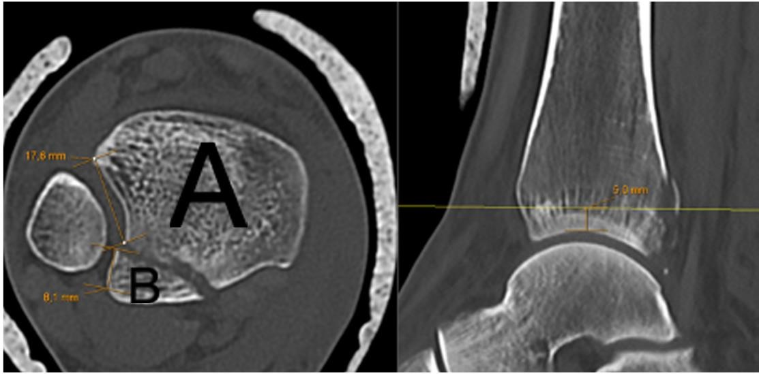
Figure 2 – Measurement of the notch involvement of the posterolateral fragment 5 mm cranial to the tibia plafond.
The distance from apex of the posterior fragment to the fracture in the fibular notch (B), and from apex of the intact tibia (A) to the fracture line. Example of notch involvement of posterolateral fragment: B/(B+A) x 100%. In
this example A= 17.6 mm, B = 8.1 mm: 8.1/25.7 x100% = 31,5%

Exclusion criteria:
- Non-compliant patient, i.e.: dementia, alcohol- or substance abuse
- ASA-4 patients
- Known congenital bone decease
- Pathological fractures
- Immunocompromised patients
- Tourists or patients on a short-term work/study permit
- Previous injury or condition of the ipsilateral ankle or ipsilateral lower extremity with a resulting dysfunction
- Poorly controlled diabetes mellitus
- Patients with known arterial insufficiency
- Open fractures
- Severely traumatized patients (ISS>16)

A flow chart illustrating the inclusion, specified treatment options depending on the size of the PMF and follow-up regime is included below (Figure 1).
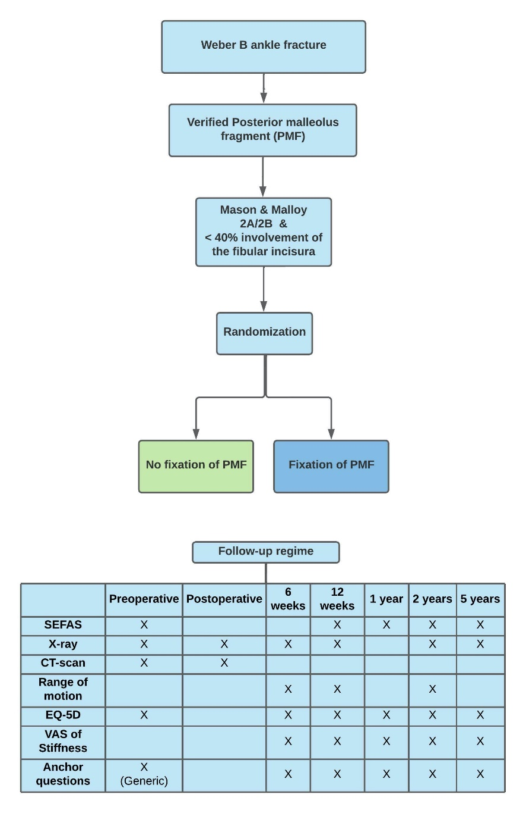
Figure 1– Inclusion of patients, specified treatment options depending on randomization and follow-up regime.
SEFAS – Self-reported Foot and Ankle Score, CT – Computer Tomography, EQ-5D - EuroQoL 5L - health-related quality of life, VAS – Visual analogue scale
Radiology
Plain radiographs with measurement of the PMF on lateral radiographs have been the traditional assessment of these fragments.²² Bartonicek et. al.¹ concluded that it is impossible to assess the size, form and anatomy of the posterior malleolar fracture on lateral radiographs. They conclude that for accurate assessment and preoperative preparation of these fractures computed tomography (CT) is needed. Axial CT images will be used for inclusion in the study.

Surgical treatment:
All operations are performed by surgeons that are experienced with both surgical approaches. One of the attending surgeons must have participated in five ORIF of posterolateral fragments. Time of surgery is based on assessment of the soft tissue status of the ankle and on time-based criteria. If swelling or other soft tissue injury prevents immediate surgery, it will be delayed the necessary time needed to prevent complications.

Non-fixation of the PMF:
A supine position of the patient is recommended. Fibula is openly reduced and fixed with lateral plate through a direct, lateral incision. After fixation of the lateral and/or medial malleolus the syndesmosis is tested. If it is unstable, openly reduction and fixation with one or two screws is performed.

Fixation of the PMF:
A prone position of the patient is recommended. Skin incision is approximately midline between the lateral border of Achilles tendon and posterior border of lateral malleolus. Careful dissection down to the fascia to avoid injury to the sural nerve which is usually found medial to the incision. Proximally the incision may be extended in a lateral direction, allowing easier access to lateral fibula anterior to the peroneal muscle. We recommend fixation of the fibular fracture after the posterior malleolus fragment. The order of fragment fixation is determined by the surgeon. Fractures can be fixed with plate on either side of the peroneal tendons/muscles.

In both groups:
If a medial malleolus fracture is present, it is treated with ORIF.
Small avulsions from medial malleolus can be left without fixation.
Deltoid ligament injuries are repaired if incarcerated between medial malleolus and talus.

The posteromedial fragment in Mason and Molloy type 2B will be fixed with one or more screws, or plate, if this fragment is displaced more than 2 mm. Small shell-like or comminuted posteromedial fragments may be left without fixation.

A Tillaux-Chaput or Wagstaffe fragment is fixed with suture anchor, plate, screw or pin if displaced >2 mm depending on size and comminution of the fragment.^{23–25}
The syndesmosis is then tested under fluoroscopy by first lateralizing and then external rotating the talus. If found to be unstable or single suturebutton, one or two 3.5 mm tricortical cortical screws are used to stabilize the syndesmosis in both groups.

Postoperative care:
Early range of motion is allowed. The operated ankle will not be treated with a cast postoperatively. A physiotherapist will instruct the patient at discharge or at a two-week follow-up for instructions on weight bearing and range of movement depending on the routine of the treating hospital. Weight bearing with a load of 10-20 kg the first six weeks after surgery is allowed in all groups. If syndesmosis screw fixation is used, weight bearing up to 30-40 kg is allowed from six to twelve weeks after surgery. In case of no fixation of the syndesmosis, the patient is allowed weight bearing as tolerated from six weeks after surgery.

Timeline
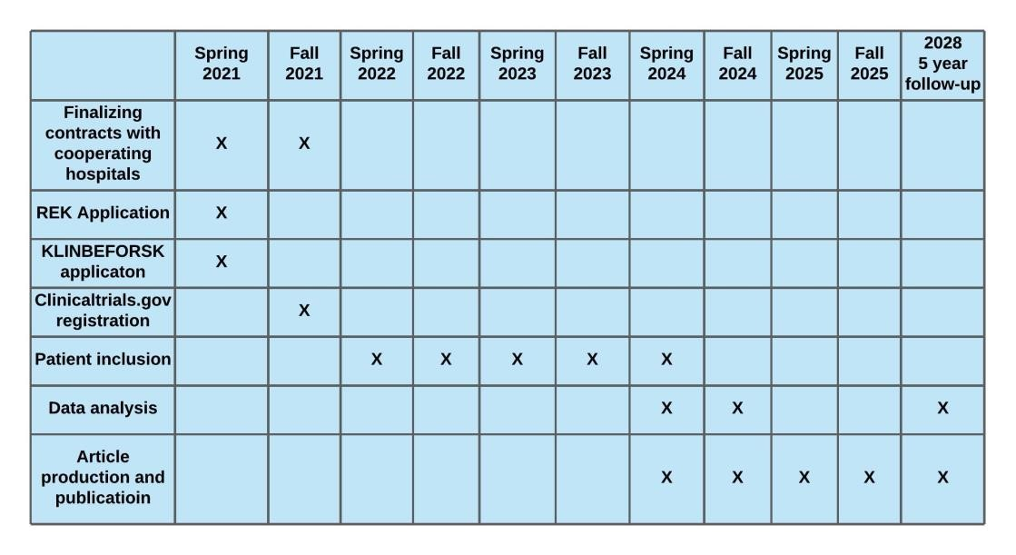
Table 1 – Study timeline with milestones of the study

Outcome evaluation
Patients will be invited to a follow-up evaluation at the outpatient clinic including clinical examination and PROMs at 6 weeks, 12 weeks, 2 years and 5 years after surgery (Figure 1). The one-year follow-up will only include PROMs.

The primary outcome measure is Self-Reported Foot and Ankle Score (SEFAS).

Secondary and exploratory outcomes include:
- EQ-5D 5 levels
- VAS of ankle Stiffness during activity (0-100)
- VAS of Pain ( 0-100)
- Dorsiflexion measured by goniometer
  - With knee in flexion and the foot on the floor. The patient leans forward as far as possible without the heel lifting. The angle between the floor and the anterior boarder of the tibia is measured with a digital goniometer (Figure 2)
- Osteoarthritis on plain radiographs at 2- and 5-years postoperative graded by the Kellgren Lawrence classification (Table 2)
- Sagittal instability of the talus by posterior drawer test per-operative after final fixation of fractures. Instability is judged as positive if the surgeon considers the talus to
dislocate posteriorly. If no posterior dislocation of the talus appears, the test is negative. The test is marked as positive or negative in Viedoc

- Anchor questions for the patient reported outcome measures

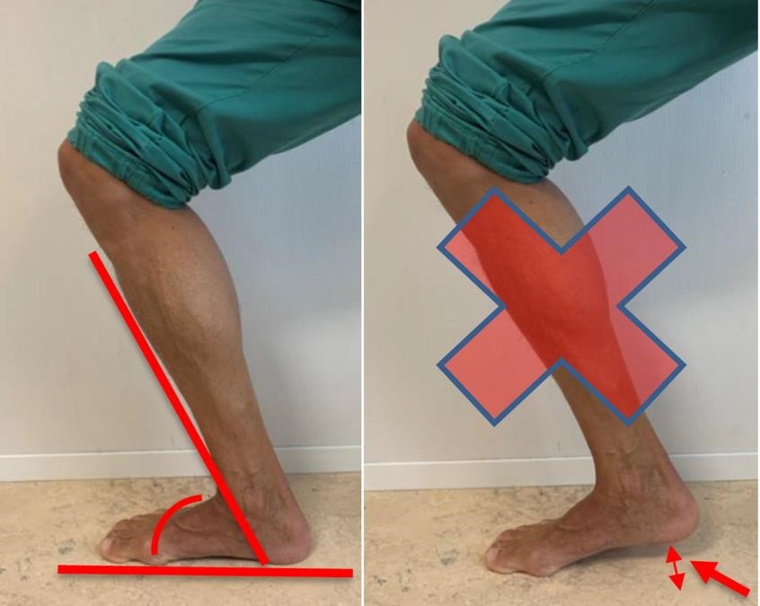
α
Figure 2- Measurement of dorsiflexion. The patient is standing with the knee flexed and leans forward as far as possible without the heel lifting from the floor. The angle between the floor and the anterior boarder of the tibia is measure with a digital goniometer. The dorsiflexion angle = 90 – α.

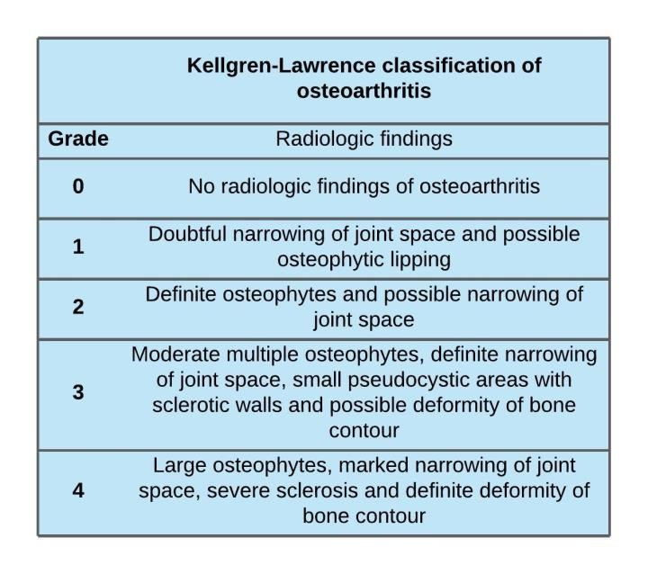
Table 2 – Kellgren-Lawrence classification. Grading performed by examination of radiographs of the ankle

The following pre-, per- and postoperative data will also be collected:

Patient demographics:
- Age
- Sex
- American Society of Anesthesiology (ASA) classification
- Patient education level (Primary school/High School/College (3 years)/University >3 years)
- Occupation: working/student/retired/disabled
- Diabetes mellitus
- Smoking
- Peripheral vascular decease.

Fracture and injury characteristics:
- Preoperative Soft-tissue problems (blisters, excoriation, other)
- Reasons for applying external fixator (if used prior to definitive surgery)
- From pre- and postoperative radiographs/CT scans:
- Posterior malleolus characteristic (Mason and Molloy classification) - Size of posterior malleolus fragment on lateral radiographs
- Size of posterior malleolus fragment on axial CT scans (Figure 2)
- Posterior malleolus fibular notch involvement on axial CT scans
- 3D CT for accurate articular surface measurements
- Rate of fracture dislocations
- Malleolar involvement (bi- or trimalleolar fractures)

Treatment given
- Rate of fixation of the syndesmosis
- Surgical approach used
- Time from injury to definitive surgery (days)
- Length of stay (days)
- Length of stay postoperative (days)
- Duration of surgery (minutes)
-

Complications
- Fracture related infections (FRI) ²⁷
- Nerve injuries
  - Injury to n. suralis, n. peroneus superficialis, n. peroneus profundus or n.
tibialis anterior defined as loss of sensation distal to ankle in areas innervated by these nerves.
- Mechanical irritation from osteosynthesis
- Removal of osteosynthesis material
- Time absent from work (sick leave)

Reoperations
- Any reoperation due to complications or failure of primary surgery
- Including local problems with hardware, but excluding removal of nonsymptomatic implants and preplanned removal (such as syndesmotic screws)

Ethical considerations
None of the surgical methods can be considered experimental as they are in conventional use at our clinic and several other level 1 trauma centers.^{2,5,7,28} Participation in the study will not cause any delay of treatment compared to conventional care, neither will patients have any extra expenses related to follow-up evaluation. If patients have any concerns throughout the study period, they will be offered an extra follow-up by one of the participating surgeons.

As there is no clear evidence supporting the choice to fixate, or not fixate, the posterior malleolus fracture, the study can contribute with new knowledge thereby contributing to a more evidenced-based approach in treating these patients.

We have been granted approval to conduct the study from the Regional Committees for Medical and Health Research Ethics (REC). REC ref.nr: 2021/255548. Every patient will have to give their written, informed consent prior to inclusion in the study.

Statistics
The primary outcome of difference between groups will be analyzed with an analysis of covariance (ANCOVA) with SEFAS at one year with baseline as covariate. Change in SEFAS over time (Baseline - 3 months – 1 year – 2 years – 5 years) will be analyzed with linear mixed effect models.

The Student t-test for continuous variables and chi-squared test for categorical variables will be used.

A power of 90% with a priori significance level of 0.05 requires 86 patients in each arm of randomization. A difference between groups of five points is considered to be a clinically relevant difference. Accounting for 20% lost to follow-up or drop out, we aim at including 104 patients in each group. The total number of patients will be 208.

VI. Dissemination of results
The study is intended to result in a PhD for Jostein Skorpa Nilsen. Results will be presented at both national and international conferences.

Further, several papers, published in internationally renowned peer-reviewed journals, are intended with the following preliminary titles:
- Randomized Controlled Trial comparing non-fixation with fixation of posterior malleolus fractures in Weber B ankle fractures – 2-year results
- Randomized Controlled Trial comparing non-fixation with fixation of posterior malleolus fractures in Weber B ankle fractures – 5-year results
- Osteoarthritis after ankle fractures involving the posterior malleolus
- Clinical relevance of postoperative step off in posterior malleolus fracture
- Economic impact of ankle fracture on patient’s daily life
- Articulate surface involvement in posterior malleolus fractures and clinical relevance – a 3D CT analysis

References
- Bartoníček J, Rammelt S, Kostlivý K, Vaněček V, Klika D, Trešl I. Anatomy and classification of the posterior tibial fragment in ankle fractures. Arch Orthop Trauma Surg. 2015;135(4):505-516. doi:10.1007/s00402-015-2171-4
- Pilskog K, Gote TB, Odland HEJ, et al. Traditional Approach vs Posterior Approach for Ankle Fractures Involving the Posterior Malleolus. Foot Ankle Int. 2020.
doi:10.1177/1071100720969431
- Cöster MC, Rosengren BE, Karlsson MK, Carlsson Å. Age- and Gender-Specific Normative Values for the Self-Reported Foot and Ankle Score (SEFAS). Foot Ankle
Int. 2018;39(11):1328-1334. doi:10.1177/1071100718788499
- Stufkens SAS, Bekerom MPJ Van Den, Kerkhoffs GMMJ, Hintermann B, Dijk CN Van. Long-term outcome after 1822 operatively treated ankle fractures : A systematic review of the literature. Injury. 2011;42(2):119-127. doi:10.1016/j.injury.2010.04.006
- Mason LW, Kaye A, Widnall J, Redfern J, Molloy A. Posterior Malleolar Ankle Fractures: An Effort at Improving Outcomes. JB JS open access. 2019;4(2):e0058. doi:10.2106/JBJS.OA.18.00058
- Mingo-Robinet J, López-Durán L, Galeote JE, Martinez-Cervell C. Ankle fractures with posterior malleolar fragment: Management and results. J Foot Ankle Surg.
2011;50(2):141-145. doi:10.1053/j.jfas.2010.12.013
- Hoogendoorn JM. Posterior Malleolar Open Reduction and Internal Fixation Through a Posterolateral Approach for Trimalleolar Fractures. JBJS Essent Surg Tech.
2017;7(4):e31. doi:10.2106/JBJS.ST.17.00016
- Gandham S, Millward G, Molloy AP, Mason LW. Posterior malleolar fractures: A CT guided incision analysis. Foot. 2020;43. doi:10.1016/j.foot.2019.101662
- Tornetta P, Ricci W, Nork S, Collinge C, Steen B. The posterolateral approach to the tibia for displaced posterior malleolar injuries. J Orthop Trauma. 2011;25(2). doi:10.1097/BOT.0b013e3181e47d29
- Verhage SM, Boot F, Schipper IB. Open reduction and internal fixation of posterior malleolar fractures using the posterolateral approach. 2014:812-817. doi:10.1302/0301-620X.98B6.36497
- Miller AN, Carroll EA, Parker RJ, Helfet DL, Lorich DG. Posterior Malleolar
Stabilization of Syndesmotic Injuries is Equivalent to Screw Fixation. Clin Orthop Relat Res. 2010;468(4). doi:10.1007/s11999-009-1111-4
- Gardner MJ, Brodsky A, Briggs SM, Nielson JH, Lorich DG. Fixation of posterior malleolar fractures provides greater syndesmotic stability. Clin Orthop Relat Res.
2006;447(447). doi:10.1097/01.blo.0000203489.21206.a9
- Tosun B, Selek O, Gok U, Ceylan H. Posterior Malleolus Fractures in Trimalleolar Ankle Fractures: Malleolus versus Transyndesmal Fixation. Indian J Orthop.
2018;52(3):309-314. doi:10.4103/ortho.IJOrtho_308_16
- Hermans JJ, Beumer A, De Jong TAW, Kleinrensink GJ. Anatomy of the distal tibiofibular syndesmosis in adults: A pictorial essay with a multimodality approach. J
Anat. 2010;217(6):633-645. doi:10.1111/j.1469-7580.2010.01302.x
- Jayatilaka MLT, Philpott MDG, Fisher A, Fisher L, Molloy A, Mason L. Anatomy of the Insertion of the Posterior Inferior Tibiofibular Ligament and the Posterior Malleolar Fracture. Foot Ankle Int. August 2019:107110071986589. doi:10.1177/1071100719865896
- Forberger J, Sabandal P V, Dietrich M, Gralla J, Lattmann T, Platz A. Posterolateral approach to the displaced posterior malleolus: functional outcome and local morbidity.
Foot ankle Int / Am Orthop Foot Ankle Soc [and] Swiss Foot Ankle Soc.
2009;30(4):309-314. doi:10.3113/FAI.2009.0309
- Ovaska MT, Mäkinen TJ, Madanat R, Kiljunen V, Lindahl J. A comprehensive analysis of patients with malreduced ankle fractures undergoing re-operation. Int Orthop.
2014;38(1):83-88. doi:10.1007/s00264-013-2168-y
- Amorosa LF, Brown GD, Greisberg J. A surgical approach to posterior pilon fractures. J Orthop Trauma. 2010;24(3):188-193. doi:10.1097/BOT.0b013e3181b91927
- Weber M. Trimalleolar fractures with impaction of the posteromedial tibial plafond:
implications for talar stability. Foot ankle Int. 2004;25(10):716-727. doi:10.1177/107110070402501005
- Little MTM, Berkes MB, Lazaro LE, Sculco PK, Helfet DL, Lorich DG. Complications following treatment of supination external rotation ankle fractures through the posterolateral approach. Foot ankle Int. 2013;34(4):523-529.
doi:10.1177/1071100713477626
- Mason LW, Marlow WJ, Widnall J, Molloy AP. Pathoanatomy and Associated Injuries of Posterior Malleolus Fracture of the Ankle. Foot Ankle Int. 2017;38(11):1229-1235. doi:10.1177/1071100717719533
- Meijer DT, Doornberg JN, Sierevelt IN, et al. Guesstimation of posterior malleolar fractures on lateral plain radiographs. Injury. 2015;46(10):2024-2029. doi:10.1016/j.injury.2015.07.019
- Rammelt S, Bartoníček J, Neumann AP, Kroker L. Fractures of the anterolateral tibial rim: The fourth malleolus. Unfallchirurg. 2021;124(3):212-221. doi:10.1007/s00113021-00959-y
- Rammelt S, Bartoníček J, Schepers T, Kroker L. Fixation of anterolateral distal tibial fractures: the anterior malleolus. Oper Orthop Traumatol. 2021;33(2):125-138. doi:10.1007/s00064-021-00703-0
- Fisher A, Bond A, Philpott MDG, et al. The anatomy of the anterior inferior tibiofibular ligament and its relationship with the Wagstaffe fracture. Foot Ankle Surg.
2021;27(3):291-295. doi:10.1016/j.fas.2021.01.003
- B.G., Weber VHHB. Classification of ankle fractures. Die Verletzungen des oberen Sprung-gelenkes. 1972;(2nd ed.).
- Metsemakers WJ, Morgenstern M, McNally MA, et al. Fracture-related infection: A consensus on definition from an international expert group. Injury. 2018;49(3):505510. doi:10.1016/j.injury.2017.08.040
- McHale S, Williams M, Ball T. Retrospective cohort study of operatively treated ankle fractures involving the posterior malleolus. Foot Ankle Surg. 2020;26(2):138-145.
doi:10.1016/j.fas.2019.01.003

